**DAILY ONLINE ACTIVITIES SUMMARY**

|  |  |  |  |  |  |  |  |  |
| --- | --- | --- | --- | --- | --- | --- | --- | --- |
| **Date:** | 19-06-2020 | | | | | **Name:** | Anvitha H M | |
| **Sem & Sec** | 4th ‘A’ | | | | | **USN:** | 4AL18CS010 | |
| **Online Test Summary** | | | | | | | | |
| **Subject** | | Microcontroller and embedded systems | | | | | | |
| **Max. Marks** | | 20 | | **Score** | | | 13 | |
| **Certification Course Summary** | | | | | | | | |
| **Course** | Introduction to information security. | | | | | | | |
| **Certificate Provider** | | | Great learning academy | | **Duration** | | | 7 hours |
| **Coding Challenges** | | | | | | | | |
| **Problem Statement:** Program in java to find smallest positive integer. | | | | | | | | |
| **Status:** Executed | | | | | | | | |
| **Uploaded the report in Github** | | | | | YES | | | |
| **If yes Repository name** | | | | | <https://github.com/alvas-education-foundation/Anvitha-H-M> | | | |
| **Uploaded the report in slack** | | | | | Yes | | | |

**Online test:**

The online test was on module 4 which was all of objective type. The questions are optimal and easy. There were 20 questions for 30 minutes. The score that I got was 13/20.

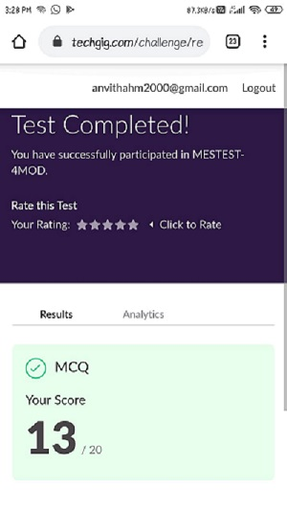

**Certification course:**

Introduction to information security.

The course includes detailed explanation on cryptography and introduction to software security.



Online coding challenge

The programing statement of the day is

“Program to Count total set bits in all numbers from 1 to n.”

Solution: Executed and uploaded in Github repository.

Link: <https://github.com/alvas-education-foundation/Anvitha-H-M>

